CREATIVE SPACES – INSPIRING CREATIVE WRITING

TEACHERS’ NOTES

One of the most iconic images associated with Dylan Thomas is the Boat House in Laugharne, where he and Caitlin and their children lived for many years. In particular, it is his writing shed above the Boat House which appeals, due to the very evocative natures of the interior and its romantic, solitary quality.
This unit encourages students to learn a bit about this place, and to research other places which creative artist have made for themselves, as writing or creating sanctuaries. Students may be familiar with Roald Dahl’s writing shed, or may have visited the houses of famous writers and poets. They may also know how J.K.Rowling did all her writing in the anonymity of a cafe.
The unit offers a chance to study images in close detail and to make notes, and to use this material to inspire their own ideas about creating a place of their own. Some may already have created spaces of this kind, or are familiar with studies and studios in their own homes.
A current creative project linked to the writing shed is the travelling version. Learn about the Dylan Thomas Shed project around Wales in his centenary year on
http://www.bbc.co.uk/news/uk-wales-south-west-wales-26180995
Resources for this unit include a brief powerpoint about Dylan Thomas’s writing shed and a task sheet for students including links to two websites which provide a wide range of examples of different kinds of creative spaces – both for living writers, poets and artists, and from the past.
These are:
http://www.theguardian.com/books/series/writersrooms.

and

http://www.huffingtonpost.co.uk/2012/06/11/famous-writers-retreats_n_1586807.html

These may be used as elements of personal background research, or presented as a class resource.

CREATIVE SPACES – CREATIVE WRITING

This is the interior of Dylan Thomas’s writing shed above The Boat House in Laugharne. He wrote some of his work here, though not all. His first poem here was On St John’s Hill. It has become the place associated with him as a poet and writer, and is kept as it would have been.
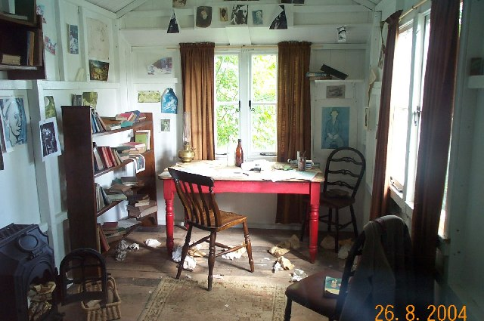

Look carefully at the interior of Dylan Thomas’s writing shed in Laugharne. Label it on this page with any impressions which you may form – note the details in it; use adjectives which capture the mood and atmosphere; express your thoughts as similes.
Photo: Richard Knights Licensed for reuse under CC Licence http://www.geograph.org.uk/photo/15855
WRITING REPONSES BASED ON THIS THEME:
- Imagine you are Dylan Thomas revisiting his writing shed and peering in through the window. Write your impressions and imagined memories of being there in years past, escaping from the noise and tension of marriage, desperate to earn some money, grappling with creative ideas.

- You are an American tourist, visiting Dylan Thomas’s Boat House for the first time. You look in through the window and absorb what you see. Later, you write a letter home describing his writing shed. Are you thrilled or disappointed?

- You have decided to be a creative artist of some kind – artist, poet, writer, musician. You need a place to be creative. What kind of place would it be? Write a description of it, including as many details about its contents, location, outlook, mood and atmosphere. How will it make you feel? What would you like to create there?

- Research other writers’ sheds. Read about Roald Dahl, Michael Morpurgo, Michael Rosen, Mark Haddon, Kevin Crossley-Holland and others and see the interiors of their creative spaces – all can be found on

http://www.theguardian.com/books/series/writersrooms.

Respond creatively to any one of them – either in the form of a poem, a letter to the writer, a drawing of the interior, making a small display linked to quotations.

- Have a look at a slideshow of artists’ spaces from America and Britain on this website. Which three appeal to you most? Why?
http://www.huffingtonpost.co.uk/2012/06/11/famous-writers-retreats_n_1586807.html
- Design your own ideal creative space for working, on paper or card, in a visually interesting way using cut up material from other sources, such as magazines, newspapers, coloured papers and text. Be prepared to talk about what inspires you.

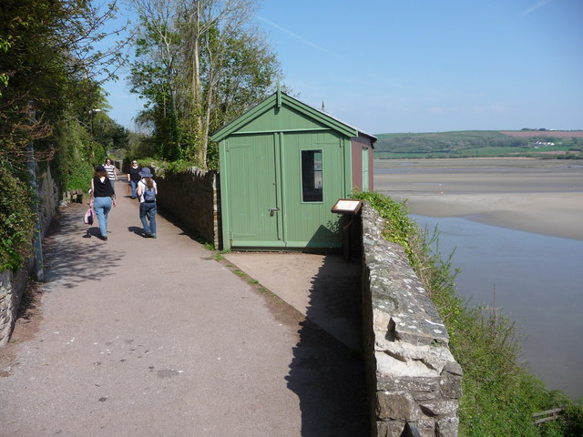
http://www.geograph.org.uk/photo/2374719/ Jeremy Bolwell
Licensed for reuse under CC LICENCE

